SonarQube installation

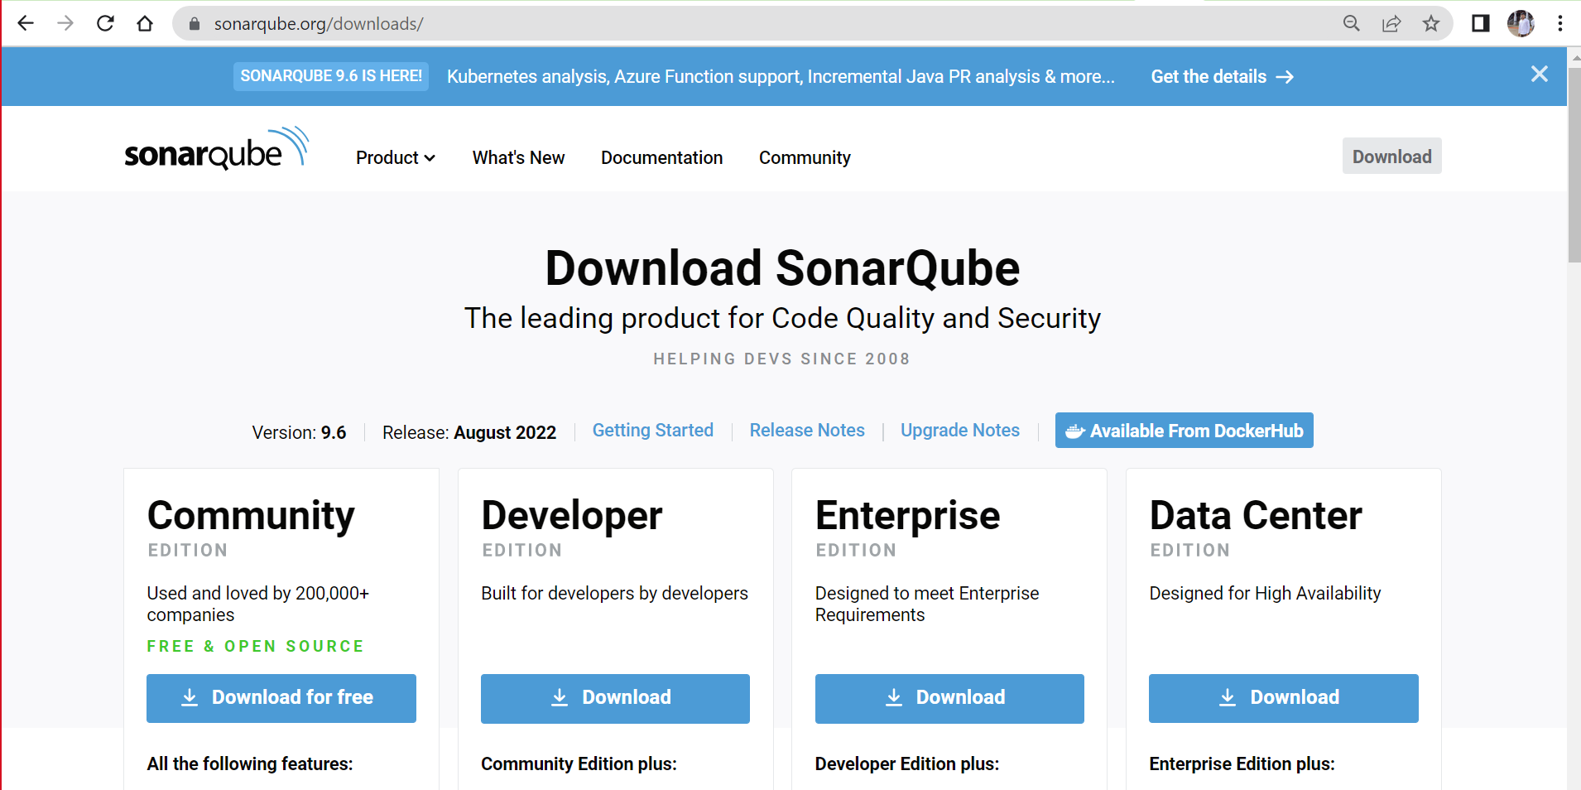

After downloading community…extract the zip file

Now open the cmd and then enter the cmd as below

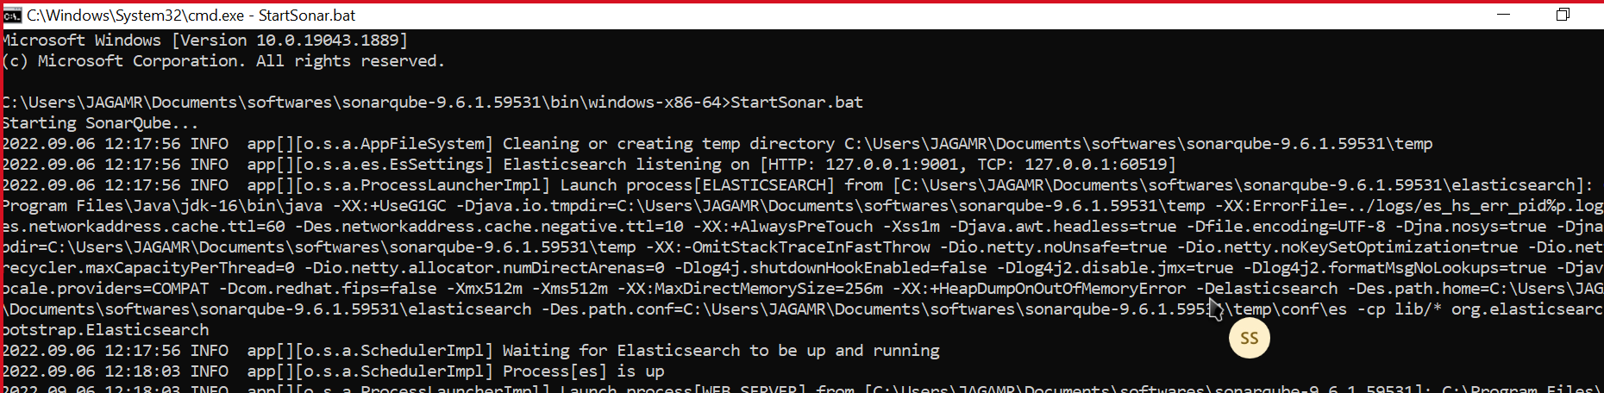

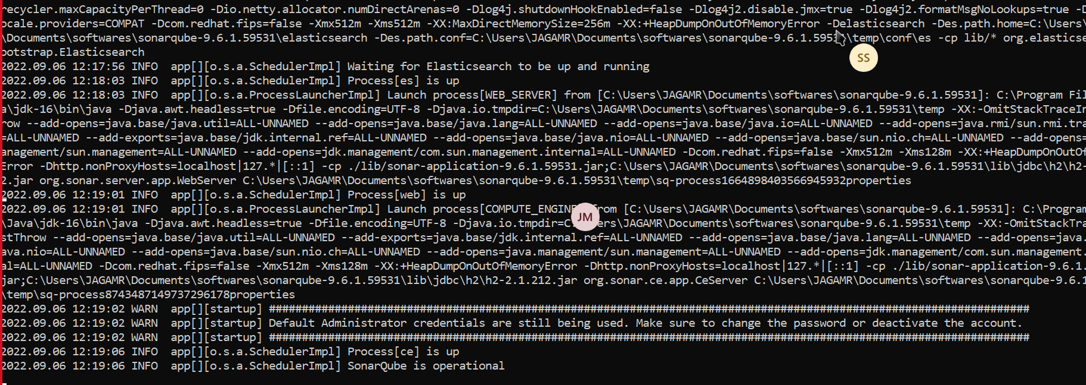

Open the localhost:9000 in chrome

Both credentials are admin,login to sonarqube

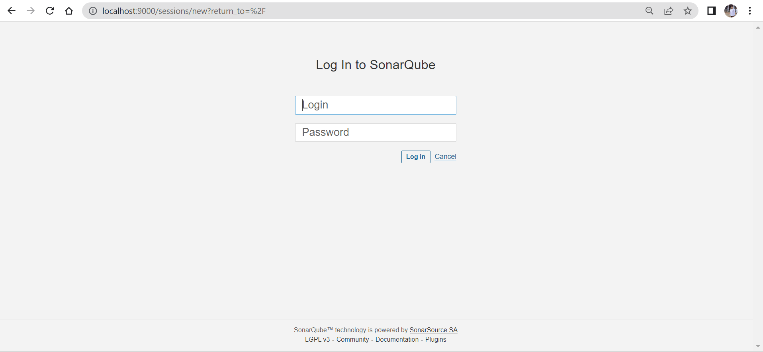

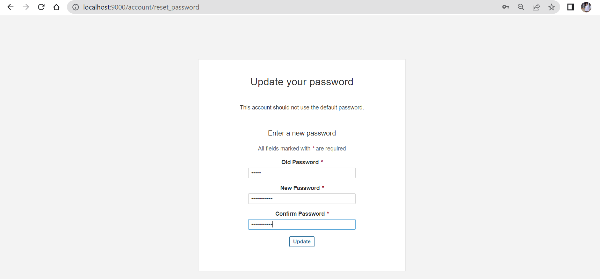

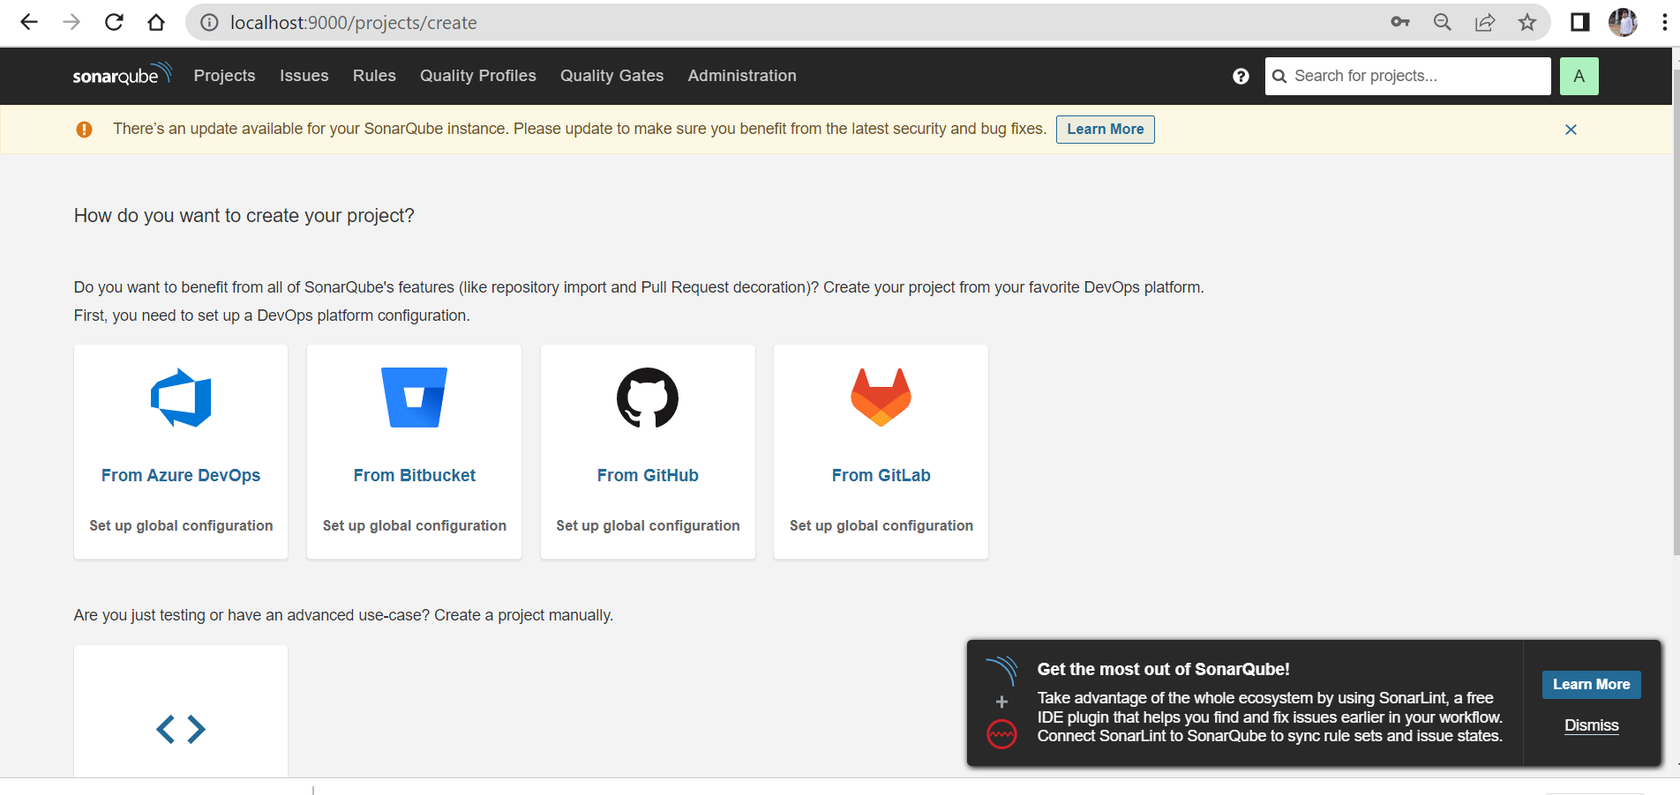

Add this in text in pom.xml (under plugins)

<plugin>  
                <groupId>org.sonarsource.scanner.maven</groupId>  
            <artifactId>sonar-maven-plugin</artifactId>  
            <version>3.8.0.2131</version>  
            </plugin>  
                  
            <plugin>  
            <groupId>org.jacoco</groupId>  
            <artifactId>jacoco-maven-plugin</artifactId>  
            <version>0.8.5</version>  
            <executions>  
              <execution>  
                  <id>prepare-agent</id>  
                  <goals>  
                   <goal>prepare-agent  
                   </goal>  
                 </goals>  
              </execution>  
              <execution>  
              <id>report</id>  
              <goals>  
              <goal>report</goal>  
              </goals>  
              </execution>  
            </executions>  
              
            </plugin>

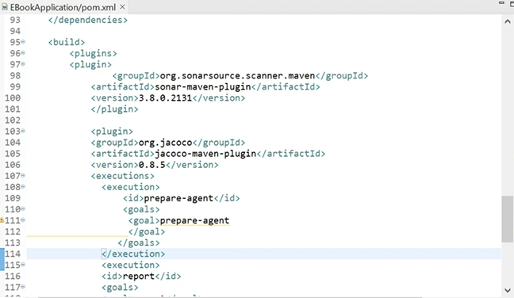

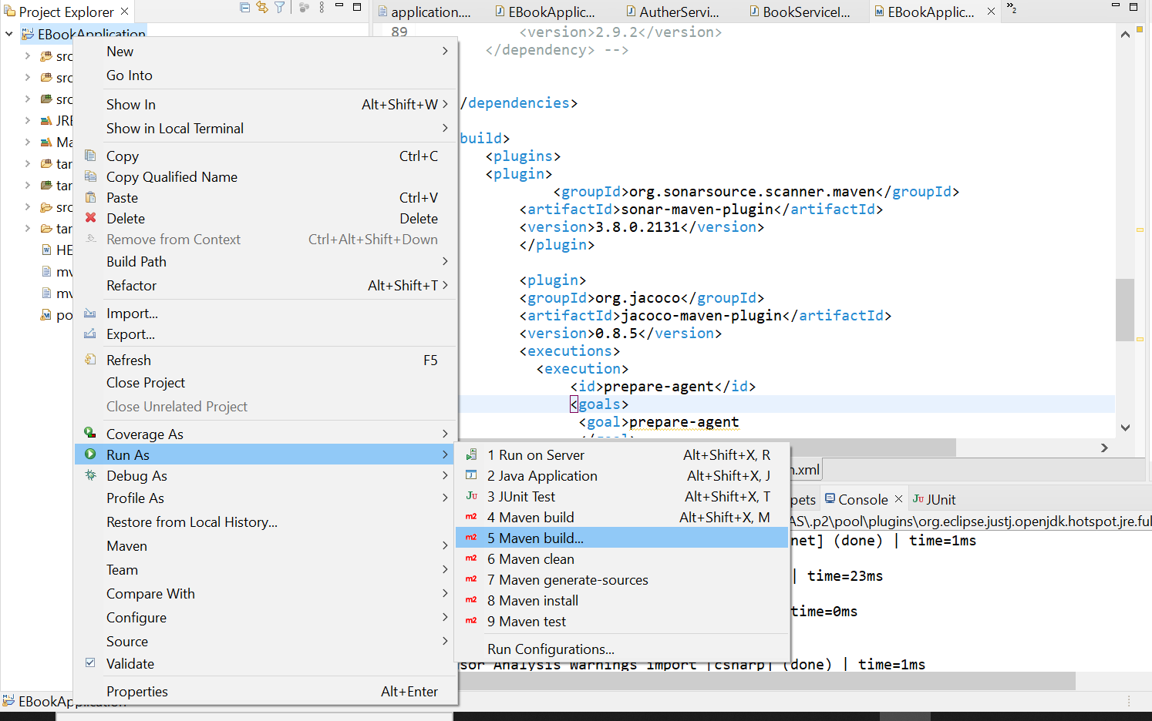

In goals text field paste the code as below ,apply and run

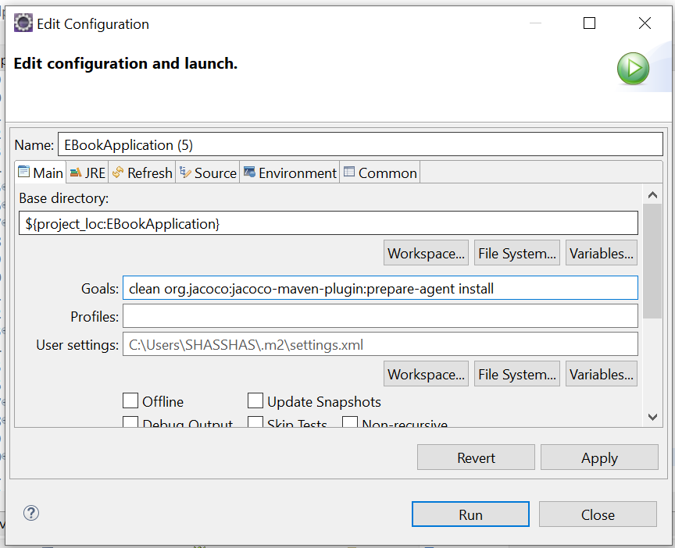

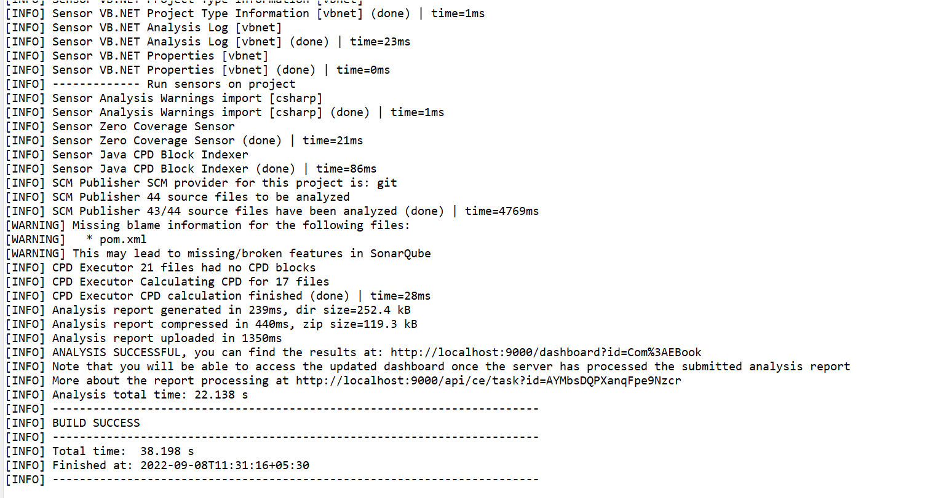

Run the sonarqube in cmd prompt..and then open sonar in chrome using localhost:9000

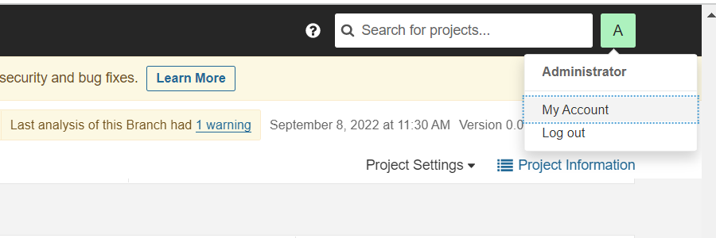

Open security and then generate token like below and copy the generated token use the token in eclipse

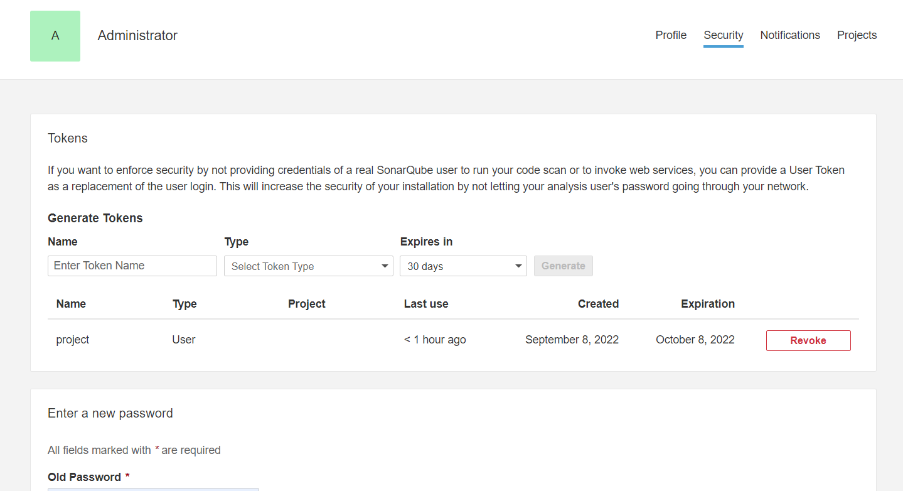

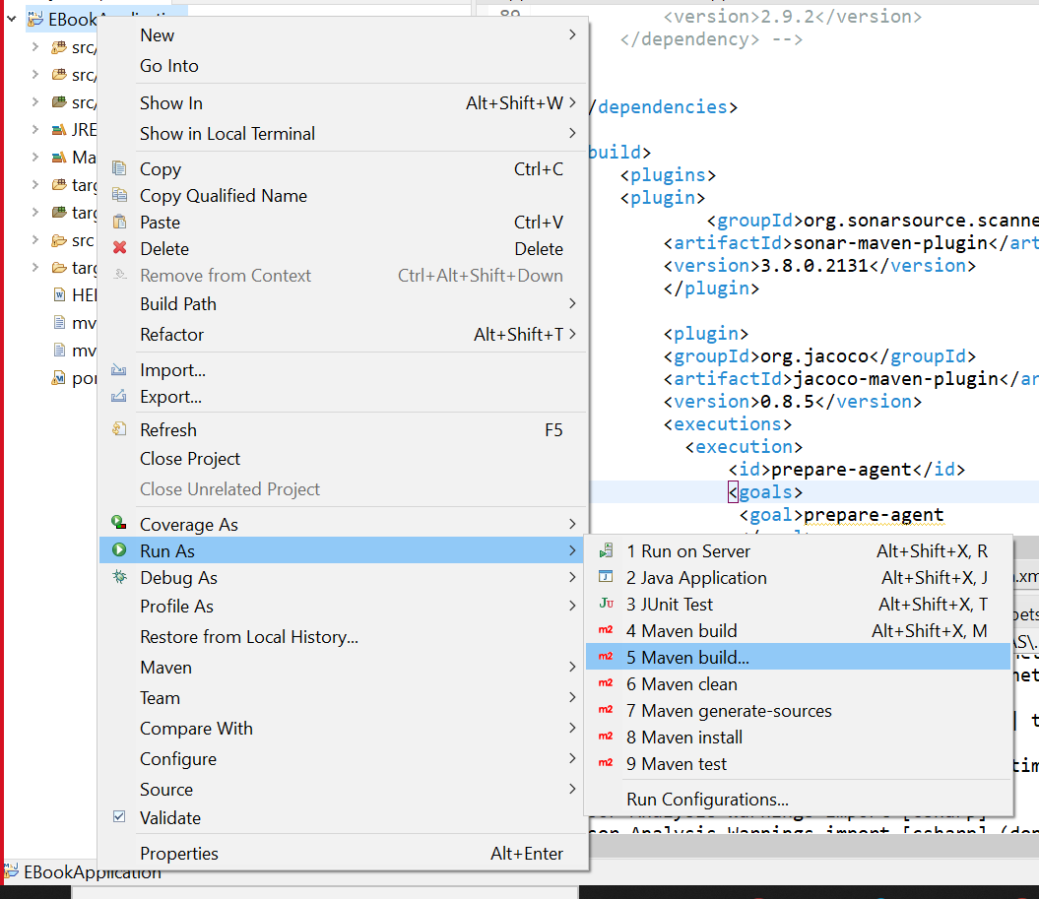

In goals text field copy paste the code like below shown format+generated token

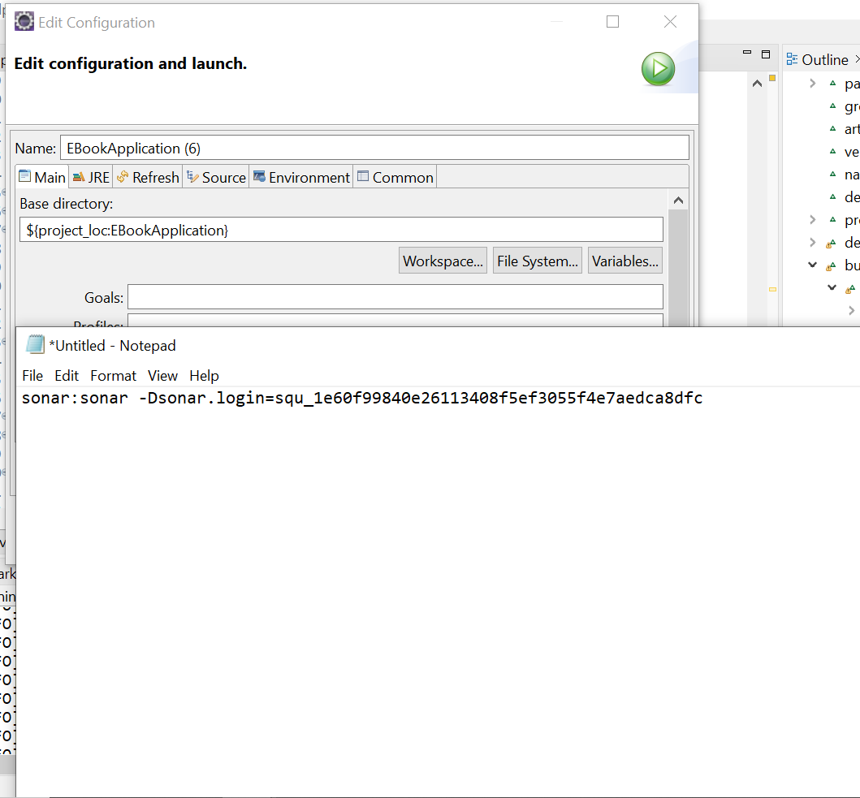

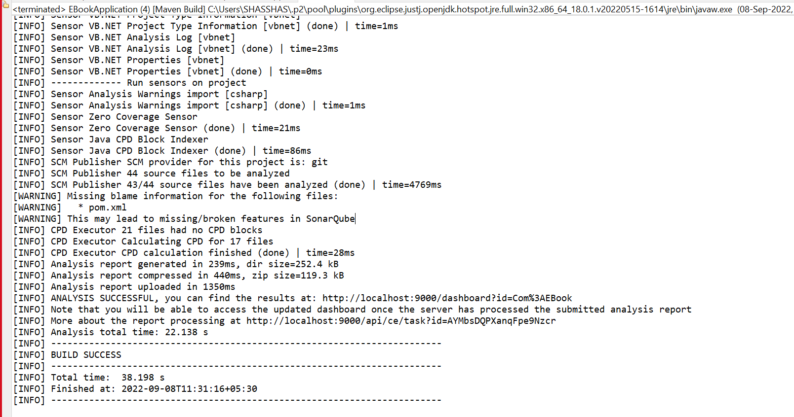

After build success open localhost:9000 in there check project

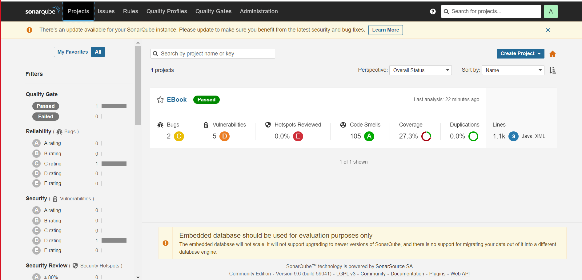

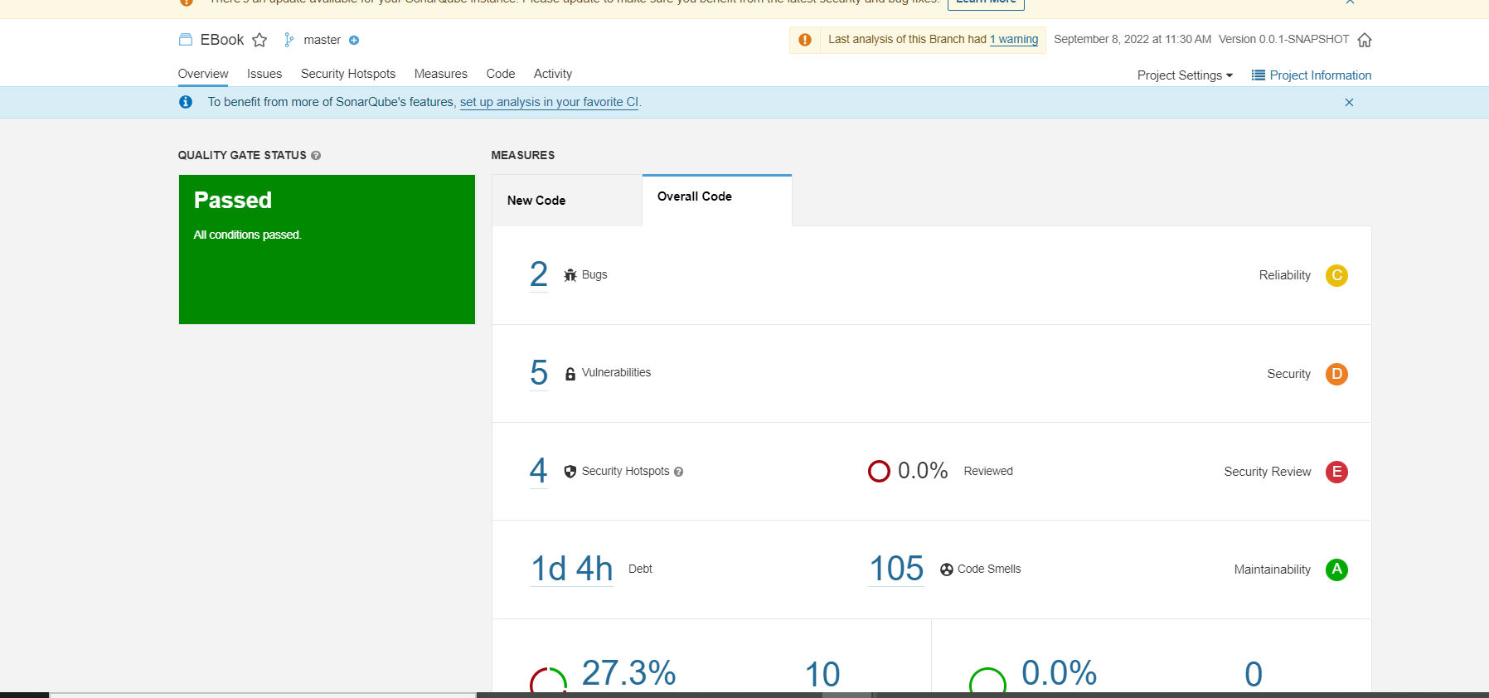

Build passed.